No Ban, No Wall: The Struggle for Immigrant Rights Under Trump

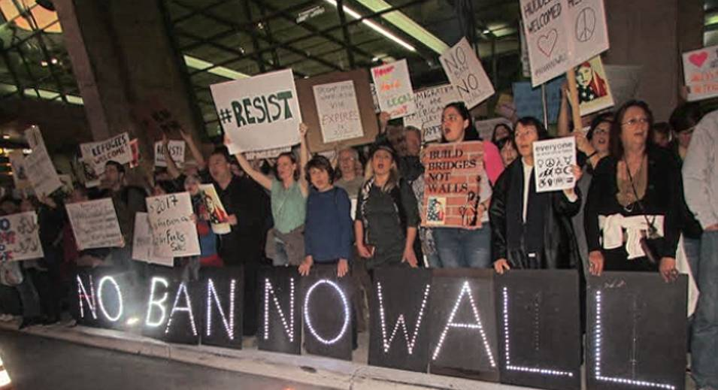

April 27, 12:30-2pm

Ingersoll 2127

Yasmine Kamel- Activist-Bay Ridge for Social Justice "Building a Movement to End Islamophobia."

Luiza Tanuri- Youth Organizer- Make the Road “Immigrant Organizing in the Times of Trump.”

Sami Disu- Independent Journalist- True Inclusion Still Elusive In New York’s Pro-Immigrant Mobilization."